

**Progress Report**

**Fall 2015-2016**

**Team Number ECE-BCC-4**

**Project P.E.T.E.R.S.**

**Team Members**

|  |  |  |  |
| --- | --- | --- | --- |
| **Name** | **Department** | **Email** | |
| Richard Taylor  Anthony Schmidt  Kenneth Hale  Antonio Foster  Brett Reich | ECE  ECE  ECE  ECE  ECE | [rrt36@drexel.edu](mailto:rrt36@drexel.edu)  [ajs469@drexel.edu](mailto:ajs469@drexel.edu)  [kch44@drexel.edu](mailto:kch44@drexel.edu)  [af558@drexel.edu](mailto:af558@drexel.edu)  [br382@drexel.edu](mailto:br382@drexel.edu) | |
|  |  | |

**Team Advisor(s)**

|  |  |  |
| --- | --- | --- |
| **Name** | **Department/Company** | **Email** |
| Christopher Peters | ECE | cpeters@coe.drexel.edu |
|  |  |  |
|  |  |  |

**Group Leader's Signature : ____________________________**

**Advisor's Signature : ____________________________**

**\*\*\*\*\*\*\*\*\*DELETE THIS SECTION\*\*\*\*\*\*\*\*\*\*\*\*\*\*\*\*\*\***

**Format**

* **Single spaced, Times New Roman (Body - 12, Headings and sub-headings - 14), Justified.**
* **Start each section on a new page**
* **Submit as a PDF to ece-sd-2015@drexel.edu and four stapled hard copies (two sided) to the box in ECE Office in front of Tanita's Desk**

**\*\*\*\*\*\*\*\*\*DELETE THIS SECTION\*\*\*\*\*\*\*\*\*\*\*\*\*\*\*\*\*\***

**1. Abstract**

The game of paintball has existed in one form or another for roughly the last 30 years, and in that time it has grown from a small group of friends engaging in archaic, backyard games to a full-fledged, multi-million dollar-a-year industry. As a result, many great technological strides have been made in terms of paintball marker, playing field, and peripheral development, but the tactics employed on the simulated battlefield and the derived annoyances that accompany them have remained largely unchanged over the years. For any seasoned paintball enthusiast, it is no secret that checking paint levels, pressurized air levels, and determining the location of teammates all involve a large diversion of attention from the task at hand and can each, in their own ways, contribute to the loss of the game. Currently, however, there is simply no work-around for keeping one’s attention totally dedicated to the game and its resulting, dynamic environment.

The P.E.T.E.R.S aims to significantly lessen or totally remove these distractions by placing the required information in the peripheral vision of the user. By way of utilizing existing consumer hardware and developing a system of network communication, this project aims to make available to the user information regarding paint level, remaining air pressure, and relative player locations in the form of a heads-up display (HUD) integrated into the paintball mask. In this way, the user can maintain a ready posture at all times in terms of directing the majority of attention to his/her surrounding environment and thereby being able to react far more readily to the bevy of situations encountered during a game.

**\*\*\*\*\*\*\*\*\*DELETE THIS SECTION\*\*\*\*\*\*\*\*\*\*\*\*\*\*\*\*\*\***

**Concise summary of the importance of the problem, objectives of the project, proposed methods of solving the problem or of seeking a solution to the problem. The abstract should not exceed half a page.**

**\*\*\*\*\*\*\*\*\*DELETE THIS SECTION\*\*\*\*\*\*\*\*\*\*\*\*\*\*\*\*\*\***

**Table of Contents**

**List of Figures**

**2. Problem Description**

Anyone who has participated in a game of paintball understands that it is fast, chaotic, and at times incredibly intense. Those who have not played should understand that the game is designed to mimic objective-based combat scenarios with all players equipped with pressurized air-powered markers that expel paint-filled, spherical membranes designed to break on impact. As with any chaotic situation, those who are able to channel their energy and focus properly are typically the ones who succeed, and this is especially true in paintball. Any action that detracts a player’s attention away from the game, whether it is for a legitimate reason or otherwise, creates a window of opportunity, however small, for the opposing team to gain the upper hand by either removing players from the game or gaining a tactical advantage by gaining ground.

During any given game of paintball, there are various inconveniences that accompany the very nature of the game and the equipment utilized to play it and inevitably force the player to divert attention away from the game. Two of these annoyances in particular involve the most vital components of the game itself: paintballs and pressurized air. In a typical game, a player must maintain an awareness of the amount of paintballs left in the hopper as well as a general idea of how much pressurized air remains in the tank feeding the marker. Currently, in order for a player to obtain an indication of the current level of either of these variables, that player must totally divert his/her attention away from the game in a conscious effort to ascertain this information leaving the player vulnerable to the opposing team and forcing him/her to reevaluate the current game situation once the desired information is gained.

**\*\*\*\*\*\*\*\*\*DELETE THIS SECTION\*\*\*\*\*\*\*\*\*\*\*\*\*\*\*\*\*\***

**Provide a general background to the problem you are proposing to solve. Establish the need for a solution to this problem.**

**\*\*\*\*\*\*\*\*\*DELETE THIS SECTION\*\*\*\*\*\*\*\*\*\*\*\*\*\*\*\*\*\***

**3. Proposed Work and Deliverables**

**\*\*\*\*\*\*\*\*\*DELETE THIS SECTION\*\*\*\*\*\*\*\*\*\*\*\*\*\*\*\*\*\***

**Describe exactly what you will do to obtain a solution. Suitable content for**

**this section would include, but is not limited to:**

**3.1. Descriptions of the methods of solution have you considered.**

**3.2. Addressing any unique principles you plan to exploit in the development of**

**your solution.**

**3.3. Mention of existing systems which relate to your problem and the solution**

**method; do you plan on utilizing these systems as modules in your**

**development of a solution?**

**3.4. Mention of the state of the art in relation to your subject matter and its impact**

**on your development of a solution.**

**3.5. Addressing the criterion which determines that an acceptable solution to the**

**problem has been obtained.**

**\*\*Also present a system flow diagram that shows a general process flow for your Senior Design Project. This should be specific to your project, for example; the Hardware development stage in the below diagram for a group working on a mechanical arm could be split into multiple smaller stages each indicating the various hardware components that are to be developed and integrated for making the arm say, servo design, joint design, sensor mount design, etc. You must also indicate in your diagram the completed, ongoing and pending work.**

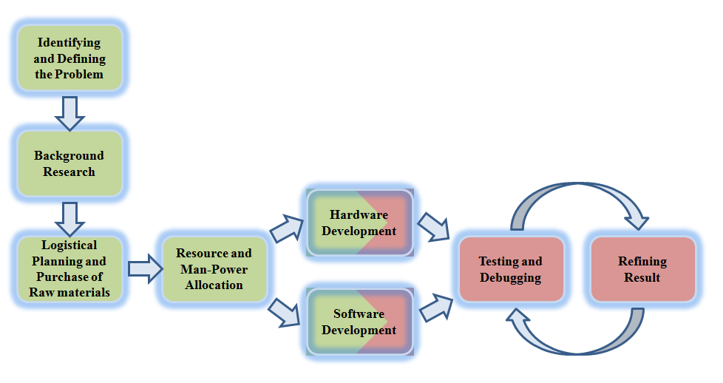

**\*\*\*\*\*\*\*\*\*DELETE THIS SECTION\*\*\*\*\*\*\*\*\*\*\*\*\*\*\*\*\*\***

**4. Completed Work**

**\*\*\*\*\*\*\*\*\*DELETE THIS SECTION\*\*\*\*\*\*\*\*\*\*\*\*\*\*\*\*\*\***

**Describe in detail the work that has been accomplished in the Fall term. Include pictures and graphs where appropriate. (In the case of coding intensive accomplishments, this would not be your code but giving the description of such.)**

**\*\*\*\*\*\*\*\*\*DELETE THIS SECTION\*\*\*\*\*\*\*\*\*\*\*\*\*\*\*\*\*\***

**5. Work Schedule / Proposed Timeline**

**\*\*\*\*\*\*\*\*\*DELETE THIS SECTION\*\*\*\*\*\*\*\*\*\*\*\*\*\*\*\*\*\***

**This is the proposed timeline for your project and should convey when various phases of the design cycle are planned to begin and end. It is recommended that you generate your timeline using project management software with the full intension of abiding by the internal and external deadlines that are dictated by such a schedule.**

**Provide this information in the form of a Gantt Chart.**

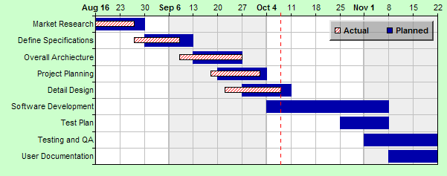

**textbook Chapter 3**

**\*\*\*\*\*\*\*\*\*DELETE THIS SECTION\*\*\*\*\*\*\*\*\*\*\*\*\*\*\*\*\*\***

**6. Industrial Budget**

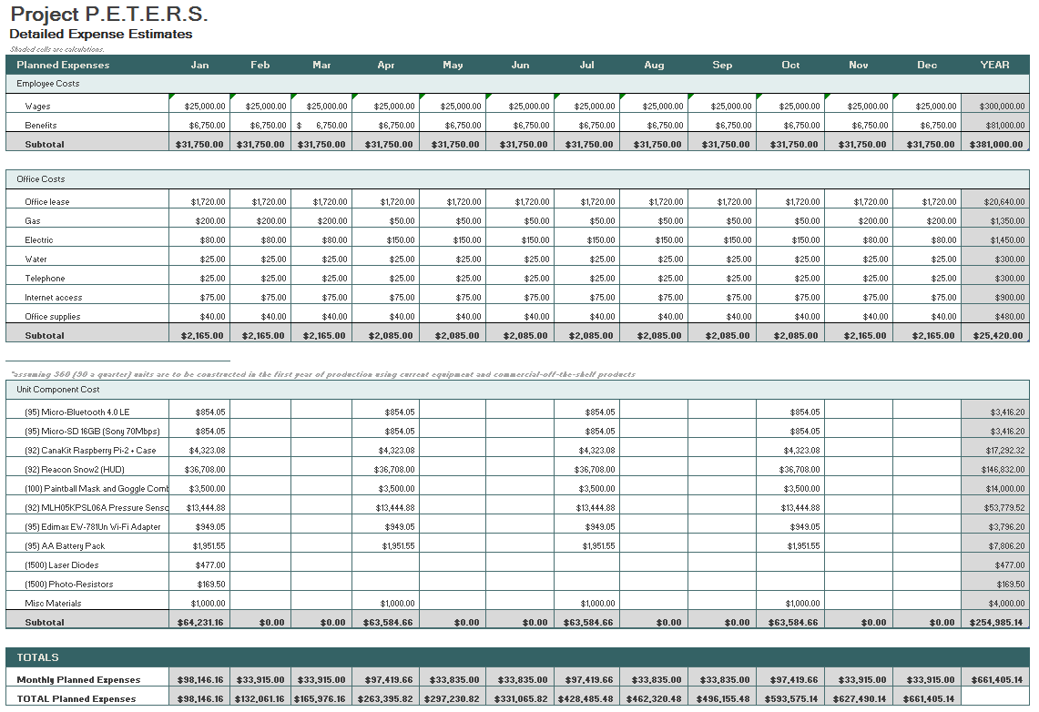

**7. Out-of-Pocket Budget**

|  |  |  |  |
| --- | --- | --- | --- |
| **Model Name** | **Unit Cost** | **Units** | **Sub-total** |
| AA Battery Pack | $19.49 | 2 | $38.98 |
| Micro-Bluetooth 4.0 LE | $8.99 | 2 | $17.98 |
| Micro-SD 16GB (Sony 70Mb/s) | $8.99 | 2 | $17.98 |
| CanaKit Raspberry Pi 2 + case | $46.99 | 2 | $93.98 |
| SNOW2 (HUD only) | $399.00 | 2 | $798.00 |
| MLH05KPSL06A | $146.14 | 2 | $292.28 |
| Photo-Resistor (20pcs) | $4.69 | 1 | $4.69 |
| SNOW2 (HUD + Goggles) | $549.00 | 1 | $549.00 |
| White LED 5mm (25pcs) | $3.54 | 1 | $3.54 |
| Edimax EW-7811Un Wi-Fi Adapter | $9.99 | 2 | $19.98 |
| Female / Male / Male 1/8th | 36.47 | 1 | $36.47 |
| shipping (for goggles) | $54.99 | 1 | $54.99 |
|  |  | Total | $1,927.87 |
|  |  | Per Person | $385.57 |

**8. Societal, Environmental or Ethical Impacts**

**\*\*\*\*\*\*\*\*\*DELETE THIS SECTION\*\*\*\*\*\*\*\*\*\*\*\*\*\*\*\*\*\***

**Textbook Chapter 2**

**\*\*\*\*\*\*\*\*\*DELETE THIS SECTION\*\*\*\*\*\*\*\*\*\*\*\*\*\*\*\*\*\***

**9. Summary/Conclusions**

**\*\*\*\*\*\*\*\*\*DELETE THIS SECTION\*\*\*\*\*\*\*\*\*\*\*\*\*\*\*\*\*\***

**Half a page**

**\*\*\*\*\*\*\*\*\*DELETE THIS SECTION\*\*\*\*\*\*\*\*\*\*\*\*\*\*\*\*\*\***

**10. References**

**\*\*\*\*\*\*\*\*\*DELETE THIS SECTION\*\*\*\*\*\*\*\*\*\*\*\*\*\*\*\*\*\***

**Please adhere to the IEEE citation style. This does not count against the 15 page limit.**

**\*\*\*\*\*\*\*\*\*DELETE THIS SECTION\*\*\*\*\*\*\*\*\*\*\*\*\*\*\*\*\*\***

**Appendix A: Design Constraints Summary**

Team Number: ECE-##

Project Title:

Summary of the Design Aspects:

**\*\*\*\*\*\*\*\*\*DELETE THIS SECTION\*\*\*\*\*\*\*\*\*\*\*\*\*\*\*\*\*\***

**One to two paragraphs summarizing all design aspects of the project. This includes hardware, software, testing protocols, lesson plans, etc.**

**\*\*\*\*\*\*\*\*\*DELETE THIS SECTION\*\*\*\*\*\*\*\*\*\*\*\*\*\*\*\*\*\***

Design Constraints:

**\*\*\*\*\*\*\*\*\*DELETE THIS SECTION\*\*\*\*\*\*\*\*\*\*\*\*\*\*\*\*\*\***

**Discuss how each design constraint was addressed in your project.**

**\*\*\*\*\*\*\*\*\*DELETE THIS SECTION\*\*\*\*\*\*\*\*\*\*\*\*\*\*\*\*\*\***

Economic:

Manufacturability:

Sustainability:

Environmental:

Ethical, health, and safety:

Social:

Political:

Standards and Regulations

**\*\*\*\*\*\*\*\*\*DELETE THIS SECTION\*\*\*\*\*\*\*\*\*\*\*\*\*\*\*\*\*\***

**Cite list of Standards/Regulations that were used or evaluated for the project (use**

**IEEE Reference-style). Make sure you understand why a certain standard is to be met by your project, you will be questioned regarding this during your presentation. Don't simply mention random standards and regulations without studying their uses and requirements.**

**\*\*\*\*\*\*\*\*\*DELETE THIS SECTION\*\*\*\*\*\*\*\*\*\*\*\*\*\*\*\*\*\***

**Appendix B: Resumes**

**\*\*\*\*\*\*\*\*\*DELETE THIS SECTION\*\*\*\*\*\*\*\*\*\*\*\*\*\*\*\*\*\***

**Provide one page resumes for each of the students.**

**\*\*\*\*\*\*\*\*\*DELETE THIS SECTION\*\*\*\*\*\*\*\*\*\*\*\*\*\*\*\*\*\***